Vivifi – Validation Test #2: Submission of Forms

In order to ensure that forms are only submitted once we have a standard validation test across all forms (artist, ensemble, and event planner submissions). There is one precursor that includes creating an account to test. In this test the account “Jessa” was created.

**Creating a New Account/Approving a New Account:**

1. User must navigate to site name
2. From there they will click to the button on the main navigation bar “Arist” “Ensemble” or “Event Planner” (in this example we start with artist).
3. This will redirect their web page to a new page that asks them if they would like to submit a form to Vivifi site administrators to become a registered user.
4. The user then can select from two separate options: register to create a new user account or  login with existing credentials
5. In this case the user would like to register for a new account. They'll need to fill out first name, last name, a working email and a desired login username.
6. Once the user submits this (fills out completely and hits submit), it will display a message to the user that an email has been sent to the Vivifi site administrator and from there an email will be sent with their login information once their form is approved back of their registered email account that was used to register for an account.
7. On the site administrator side the administrator would need to login to the administrator login panel with existing (accurate) administrator login credentials and then hit submit.
8. The site administrator will need to select between the three email options (all three work – just different layouts).
9. The site administrator email inbox should now have the notification that a user form (artist) was submitted to to register; they should then have a pending request for the ability to activate and register an account.
10. The administrator from there should login to the existing site with existing (accurate) administrator login credentials and then hit submit.
11. The administrator should then navigate to the top drupal bar to the fifth button titled “people” and should click to this location.
12. A pop-up window should now appear that lists out all usernames, the status of their account (active, pending approval), and statistics on last access, permission, and roles.
13. The administrator should select the desired user(s) to approve and dropdown their status to “active” to activate their account.
14. Once the account status has been altered to read as “active” the pending user will receive an email to their identified email they provided to register with valid login credentials.
15. User should navigate to site using link provided in the email (step 14) to set a new password.
16. User will be prompted to set a new password. User also has the ability to alter preexisting information such as first name, last name, email address, and time settings.
17. User is now logged in and can proceed to the “artist registration” button link.

**Testing Artist Form: One Submission Only**

1. User should navigate to active “Artists” link on main navigation bar and should then click on the link titled “Artist Application”.

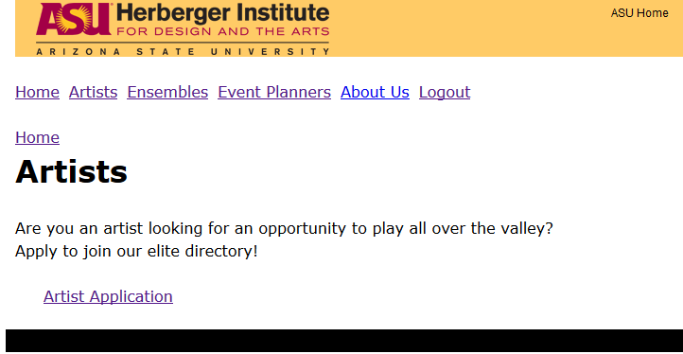

2. If correctly constructed, the site will not allow for another artist registration under the username of “Jessa”. As captured below, this is has been successfully be implemented to catch when a username tries to submit multiple entries.

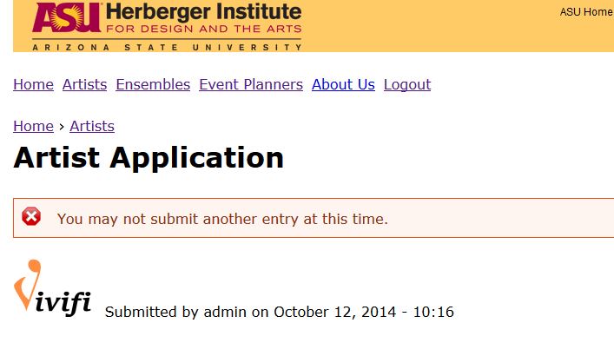

**Testing Ensemble Form: One Submission Only**

**1.** User should navigate to active “Ensembles” link on main navigation bar and should then click on the link titled “Artist Application”.

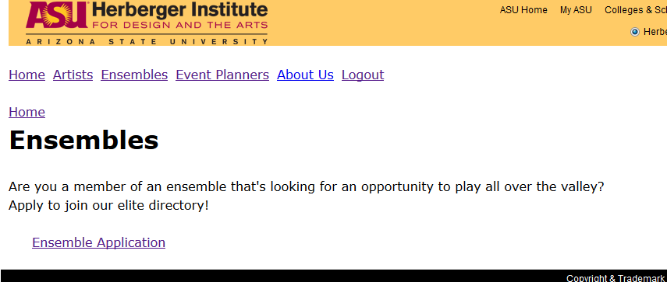

**2.** Site allows user “Jessa” to register as an ensemble because this has not been done previously. User should proceed to check all auto-populated sections for accuracy and then submit each page until complete.

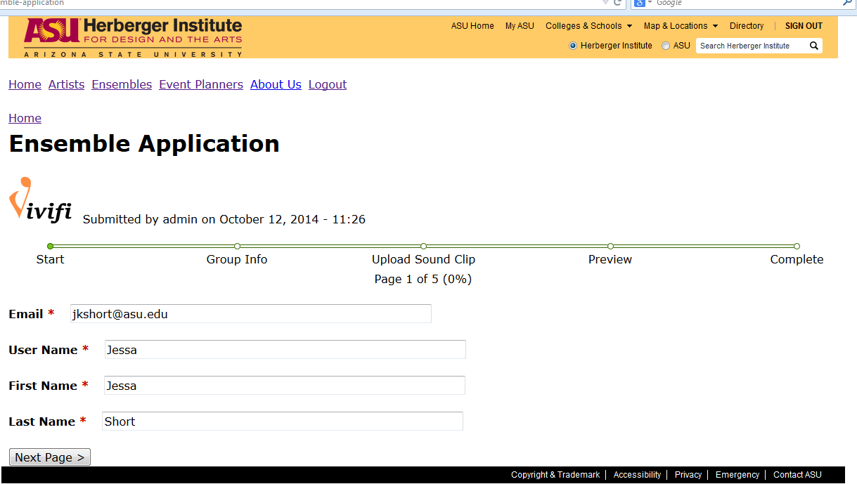

**3.** If the same user (“Jessa”) tries to submit again, this message will again appear.

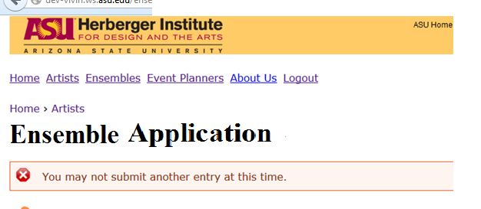

**Testing Event Planner Form: One Submission Only**

**1.** User should navigate to active “Event Planners” link on main navigation bar and should then click on the link titled “Event Planner Registration”.

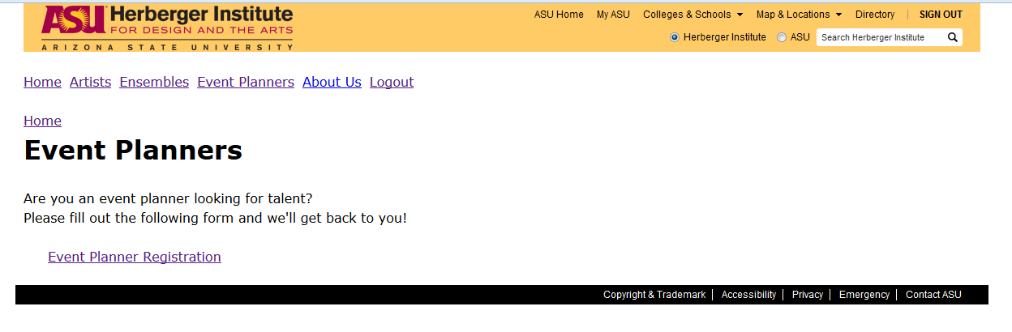

**2.** Site allows user “Jessa” to register as an event planner because this has not been done previously. User should proceed to check all auto-populated sections for accuracy and then submit each page until complete.

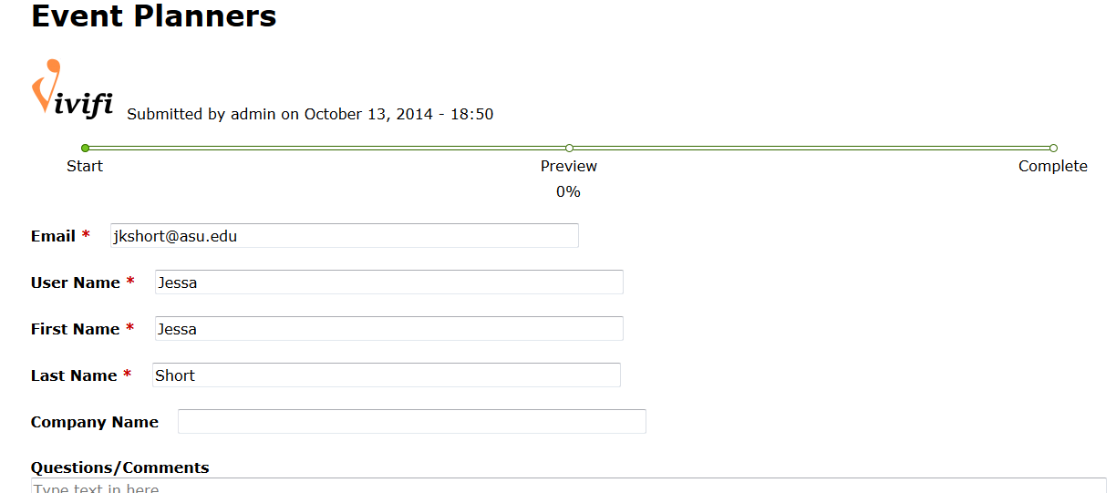

**3.** If the same user (“Jessa”) tries to submit again, this message will again appear.

